Project Report:

Unveiling Market Insights

Analysing Spending Behaviour and Identifying Opportunities for Growth

# 1. INTRODUCTION

## 

## 1.1 OVERVIEW

**In today's competitive business landscape, understanding consumer spending behaviour is crucial for any organization seeking growth opportunities. This project report presents a comprehensive analysis of market insights derived from an in-depth** study **of spending behaviour across various demographics.**

### Background and Objectives:

**The objective of this project is to gain a deep understanding of consumer spending behaviour in the current market. We aim to uncover hidden insights that can help businesses identify opportunities for growth and tailor their strategies accordingly.**

### Current Market Trends:

**The market is currently characterized by:**

* **A shift towards online shopping due to convenience and safety concerns.**
* **Increased awareness of sustainability, influencing purchase decisions.**
* **A growing preference for personalized and unique products/services.**

## 

## 1.2. PURPOSE

### Highlighting Key Trends:

* **The rise of e-commerce and the importance of a seamless online shopping experience.**
* **The growing demand for sustainable and eco-friendly products.**
* **The impact of social media on consumer choices.**

### Identifying Growth Opportunities:

* **Invest in improving online shopping platforms and customer service.**
* **Develop eco-friendly product lines and emphasize sustainability efforts.**
* **Leverage social media marketing to engage with the target audience effectively**

# 2. PROBLEM DESIGNING & DESIGN THINKING

# 

## 2.1 EMPATHY MAP

# 

## 2.2 IDEATION & BRAINSTORMING MAP

# 

# 3. RESULT

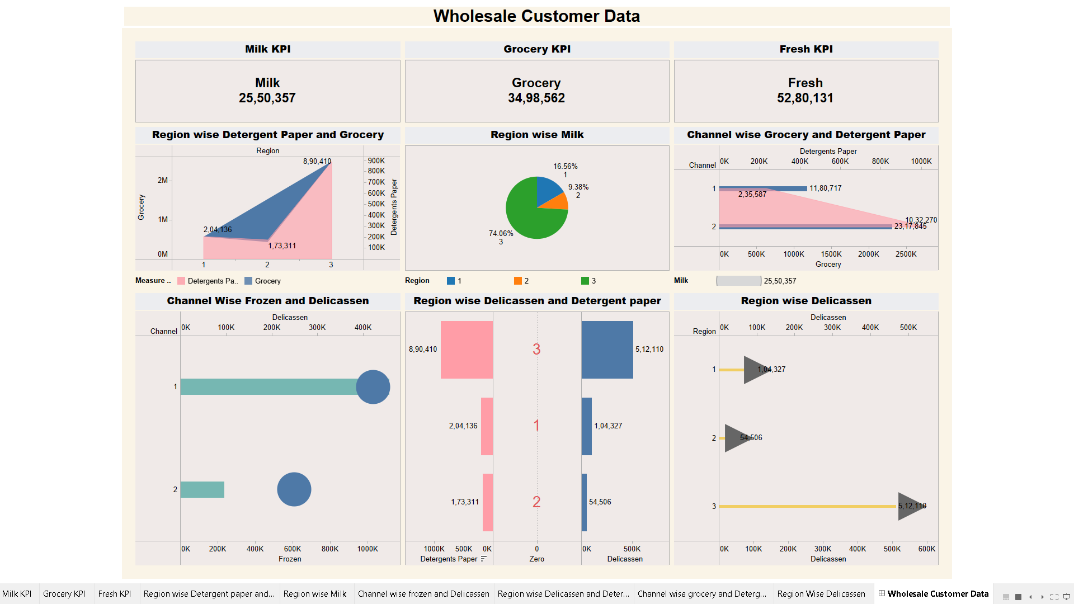**DASHBOARD**

**STORY**

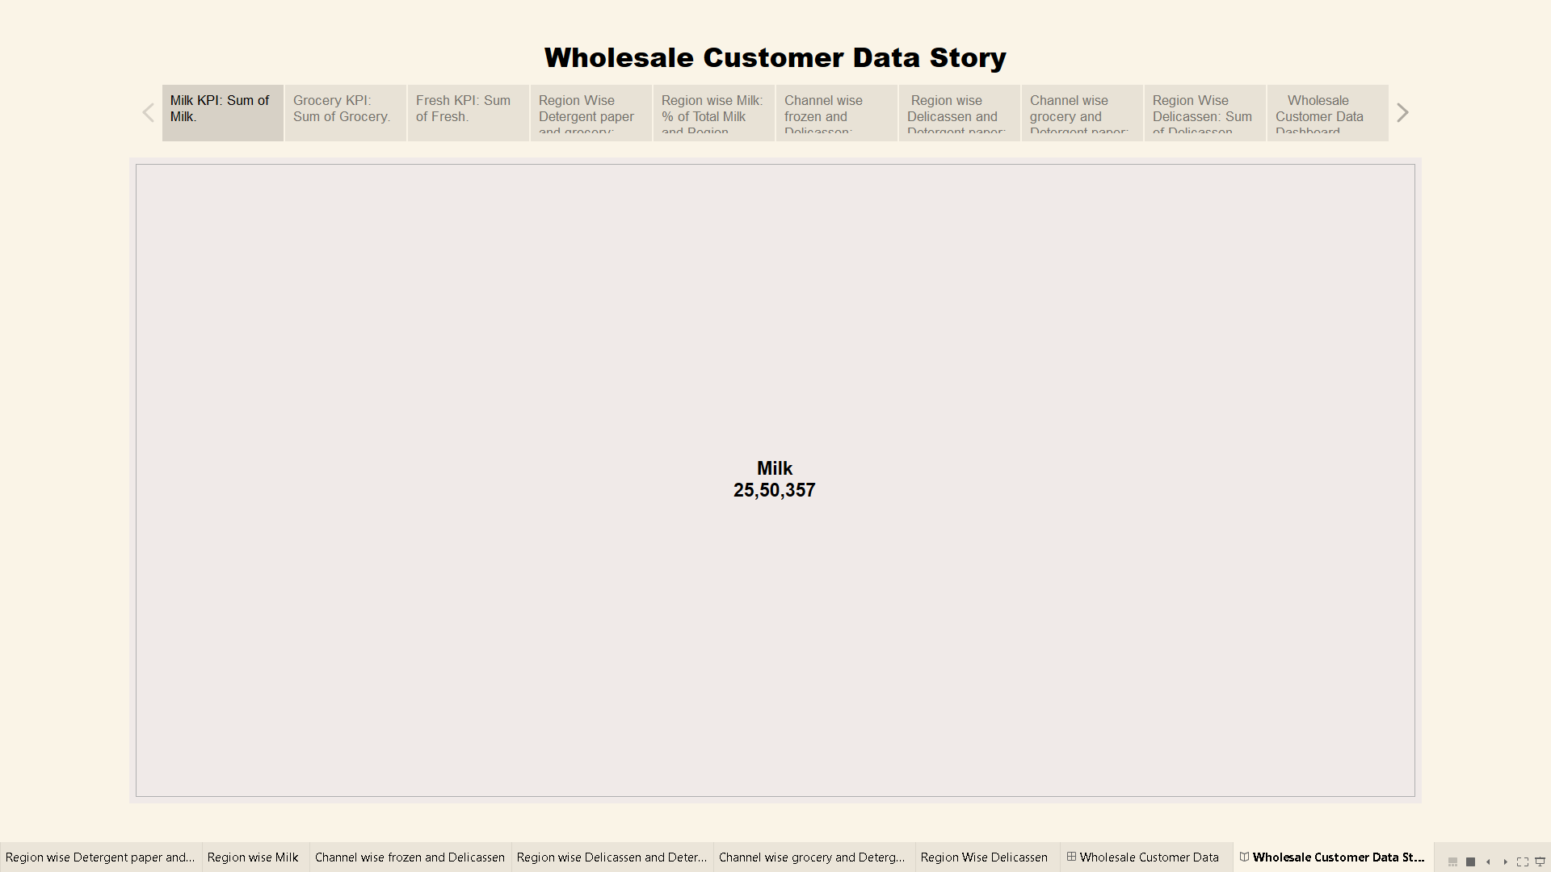

# 4. ADVANTAGES & DISADVANTAGES

Analyzing spending behavior and identifying opportunities for growth through market insights has its advantages and disadvantages. Here is a breakdown of both:

## Advantages:

1. **Informed Decision-Making**: Understanding consumer spending behavior allows businesses to make informed decisions. It helps in product development, marketing strategy, and resource allocation, leading to more effective operations.
2. **Competitive Edge**: By gaining insights into market trends and consumer preferences, a company can stay ahead of competitors. This knowledge can be used to differentiate products or services and offer something unique to consumers.
3. **Targeted Marketing:** Market insights enable businesses to tailor their marketing efforts to specific customer segments. This leads to higher conversion rates, as marketing messages resonate better with the target audience.
4. **Cost Optimization**: Understanding spending behavior helps in optimizing costs by focusing resources on high-potential areas. Businesses can avoid unnecessary expenses by eliminating strategies that do not align with consumer preferences.
5. **Risk Mitigation**: By identifying potential market threats or shifts in consumer behavior early on, businesses can proactively adapt and

## Disadvantages:

1. **Data Collection Costs**: Gathering, processing, and analyzing market data can be expensive and time-consuming. It may require significant investments in technology and research.
2. **Data Privacy Concerns:** Collecting consumer data may raise ethical concerns and legal issues related to data privacy. Striking the right balance between data collection and privacy is crucial.
3. **Data Accuracy and Reliability**: Market data is not always completely accurate or reliable. Relying on flawed data can lead to misguided decisions.
4. **Over-Reliance on Data**: Overemphasis on data can lead to a narrow focus, ignoring factors that cannot be easily quantified. This can result in missing out on valuable qualitative insights.
5. **Market Complexity**: Markets are complex and subject to various external factors, making it challenging to predict consumer behavior accurately. Economic, political, and social changes can disrupt even the most well-researched strategies.
6. **Competition:** As more businesses use market insights for decision-making, competition can intensify, making it harder to maintain a unique selling proposition.
7. **Resistance to Change**: Employees and stakeholders may resist changes based on market insights, especially if they contradict existing beliefs or practices.
8. **Limited Predictive Power:** Market insights provide historical and current information, but they may not always accurately predict future trends or consumer behavior.

**Top of Form**

# 5. APPLICATION

This has a wide range of applications across various industries and sectors. Here are some key applications:

## Retail and E-commerce:

* + Merchandising: Retailers can optimize product assortments based on consumer preferences and seasonal spending patterns.
  + Pricing Strategies: Insights can help retailers set competitive prices and implement dynamic pricing strategies.
  + Inventory Management: Understanding spending behaviour helps in managing inventory levels and reducing overstock or stockouts.

## Consumer Goods:

* + Product Development: Insights guide the creation of new products or the improvement of existing ones to align with consumer preferences.
  + Brand Positioning: Understanding spending behaviour assists in refining brand messaging and positioning to resonate with target demographics.
  + Packaging and Labelling: Packaging designs and product labels can be tailored to appeal to specific consumer segments.

## Financial Services:

* + Credit Scoring: Financial institutions use spending data to assess creditworthiness and make lending decisions.
  + Investment Strategies: Asset management firms utilize market insights to inform investment decisions and portfolio management.
  + Financial Planning: Consumers can receive personalized financial advice and budgeting tools based on their spending behaviour.

## Hospitality and Tourism:

* + Pricing and Package Offers: Hotels and airlines adjust pricing and package offers based on demand patterns and seasonal spending trends.
  + Customer Experience Enhancement: Insights can be used to improve the guest experience by tailoring services and amenities.
  + Marketing Campaigns: Tourism boards and travel agencies target promotions to specific demographics.

## Healthcare:

* + Patient Engagement: Healthcare providers use insights to engage patients in managing their health, particularly in chronic disease management.
  + Resource Allocation: Hospitals allocate resources more efficiently based on patient needs and treatment demand.
  + Pharmaceuticals: Pharmaceutical companies can develop and market medications according to consumer health spending habits.

## Technology and Software:

* + Product Features: Software developers can prioritize and design features based on user spending behaviour and preferences.
  + User Experience Optimization: Insights guide the improvement of user interfaces and customer support.
  + Subscription Models: Subscription-based businesses refine pricing models based on subscriber spending behaviour.

# 6. CONCLUSION

In conclusion, the practice of unveiling market insights through the analysis of spending behaviour and the identification of opportunities for growth is a vital strategic tool for businesses and organizations across diverse industries. This process empowers decision-makers with valuable information that can shape their strategies, enhance customer experiences, and ultimately drive success. Here are some key takeaways:

1. **Informed Decision-Making**
2. **Competitive Advantage**
3. **Customer-Centric Approach**
4. **Efficiency and Resource Optimization**
5. **Risk Mitigation**
6. **Innovation and Growth**
7. **Ethical Considerations**
8. **Flexibility and Adaptability**
9. **Collaboration and Cross-Functional Teams**
10. **Long-Term Sustainability**

In today's fast-paced and competitive business environment, the ability to unveil market insights is not only a strategic advantage but a necessity. Organizations that invest in understanding spending behaviour and identifying growth opportunities are better equipped to navigate uncertainties, seize emerging opportunities, and build lasting success. However, it's important to recognize that market insights are most valuable when they are used as part of a broader decision-making process that combines data with human judgment, creativity, and adaptability to create a well-rounded and dynamic strategy.

**Top of Form**

# 7. FUTURE SCOPE

The future scope of analysing spending behaviour and identifying opportunities for growth remains highly promising and is expected to evolve significantly. As technology advances, data collection methods become more sophisticated, and consumer behaviour continues to change, here are some key areas of future development in this field:

1. **Advanced Data Analytics**
2. **Artificial Intelligence (AI)**
3. **IoT and Sensor Data**
4. **Blockchain for Data Security**
5. **Cross-Channel Insights**
6. **Personalization at Scale**
7. **Ethical Data Usage and Privacy Compliance**
8. **Sustainability and Eco-Friendly Trends**
9. **Health and Wellness Insights**
10. **Emerging Markets and Global Expansion**
11. **Continuous Feedback Loops**
12. **Collaborative Data-Sharing**

In summary, the future of analysing spending behaviour and identifying growth opportunities is marked by technological advancements, increased data granularity, and a heightened focus on personalization and ethics. Businesses that invest in cutting-edge data analytics, adopt innovative technologies, and prioritize ethical data practices will be well-positioned to thrive in the ever-evolving landscape of consumer behaviour analysis.